Practical 1: Build Data Warehouse / Data Mart and Design Dimensional Models
Aim
To build a Data Warehouse/Data Mart for a given problem statement by identifying source tables, populating sample data, and designing Star Schema, Snowflake Schema and Fact Constellation Schema.
Theory
A Data Warehouse is a centralized repository used to store large amounts of historical data collected from different sources. It is mainly designed for analysis, reporting and decision-making rather than day-to-day transaction processing.
A Data Warehouse generally has the following characteristics:
- Subject-oriented – Data is organized around subjects such as sales, customers, products, etc.
- Integrated – Data from different sources is combined into a common format.
- Time-variant – Historical data is maintained over a period of time.
- Non-volatile – Once data is stored, it is mainly used for reading and analysis.
- It supports OLAP operations and business intelligence.
- It helps management identify trends and make better decisions.
A Data Mart is a smaller part of a Data Warehouse that focuses on a particular department or business area such as sales, finance or marketing.
Dimensional Model
A dimensional model mainly consists of:
- Fact Table – Contains numerical/measurable business data.
- Dimension Tables – Contain descriptive information about the facts.
Example:
Sales Fact
- Product_ID
- Customer_ID
- Time_ID
- Quantity
- Sales_Amount
Types of Schemas
1. Star Schema
- One central fact table.
- Multiple dimension tables directly connected to the fact table.
- Simple and fast for querying.
2. Snowflake Schema
- Extension of Star Schema.
- Dimension tables are further normalized into multiple tables.
- Reduces redundancy but increases complexity.
3. Fact Constellation Schema
- Contains multiple fact tables sharing common dimension tables.
- Useful for complex business systems.
Algorithm / Steps
- Understand the given business problem.
- Identify the required data sources.
- Identify source tables and attributes.
- Clean and transform the source data.
- Identify the business process.
- Identify the fact table.
- Identify the required dimension tables.
- Define primary and foreign keys.
- Populate the dimension tables.
- Populate the fact table.
- Design the required Star Schema.
- Normalize dimensions to create Snowflake Schema if required.
- Create multiple fact tables for Fact Constellation Schema.
- Verify relationships between tables.
- Execute sample analytical queries.
Result
The Data Warehouse/Data Mart was successfully designed and populated using dimensional modeling techniques.

Practical 2: Perform OLAP Operations
Aim
To perform various OLAP operations such as Slice, Dice, Drill-down, Roll-up and Pivot on a Data Warehouse.
Theory
OLAP (Online Analytical Processing) is a technology used for analyzing multidimensional data stored in a Data Warehouse. It allows users to view data from different perspectives and obtain useful business information.
OLAP data is generally represented using dimensions such as:
- Time , Product , Location , Customer
and measures such as:
- Sales , Profit , Quantity
OLAP Operations
1. Slice
- Selects a single value from one dimension.
- Example: Display sales only for the year 2025.
2. Dice
- Selects a subset using multiple dimensions.
- Example: Sales of laptops and mobiles in Mumbai during 2025.
3. Drill-down
- Moves from summarized data to detailed data.
- Example:
  - Year → Quarter → Month → Day
4. Roll-up
- Moves from detailed data to summarized data.
- Example:
  - Day → Month → Quarter → Year
5. Pivot
- Rotates the data dimensions to obtain a different view.
Algorithm / Steps
- Load the required Data Warehouse.
- Select the required fact table.
- Identify dimensions and measures.
- Create a multidimensional view/cube.
- Perform Slice by selecting one dimension value.
- Perform Dice by selecting multiple dimension values.
- Perform Drill-down to view more detailed information.
- Perform Roll-up to summarize detailed information.
- Perform Pivot to change the orientation of dimensions.
- Analyze the obtained results.
Result
Various OLAP operations were successfully performed on the Data Warehouse.

Practical 3: Decision Tree Classifier Using ID3/C4.5
Aim
To design and implement a Decision Tree Classifier using the ID3/C4.5 algorithm.
Theory
A Decision Tree is a supervised machine learning algorithm used for classification and prediction. It represents decisions in the form of a tree structure.
A decision tree consists of:
- Root Node – Starting point of the tree.
- Internal Nodes – Represent decision conditions.
- Branches – Represent outcomes of conditions.
- Leaf Nodes – Represent final class labels.
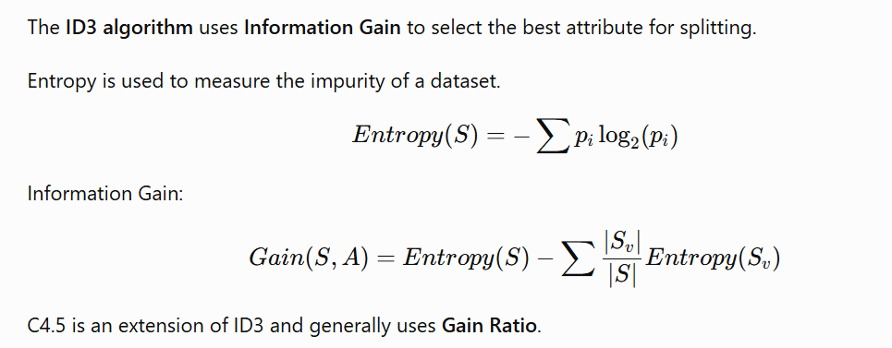Algorithm – ID3
- Start with the complete training dataset.
- Calculate the entropy of the dataset.
- Calculate information gain for every available attribute.
- Select the attribute having the highest information gain.
- Make this attribute the decision node.
- Divide the dataset according to the attribute values.
- Repeat the process for each subset.
- If all records belong to the same class, create a leaf node.
- If no attributes remain, assign the majority class.
- Continue until the decision tree is completely constructed.
- Use the generated tree to classify new data.
Result
A Decision Tree Classifier was successfully designed using the ID3/C4.5 approach.

Practical 4: Design Linear Regression
Aim
To design a Linear Regression model for predicting the dependent variable using an independent variable.
Theory
Linear Regression is a supervised learning technique used to predict a continuous numerical value.
It establishes a relationship between an independent variable \(X\) and dependent variable \(Y\).
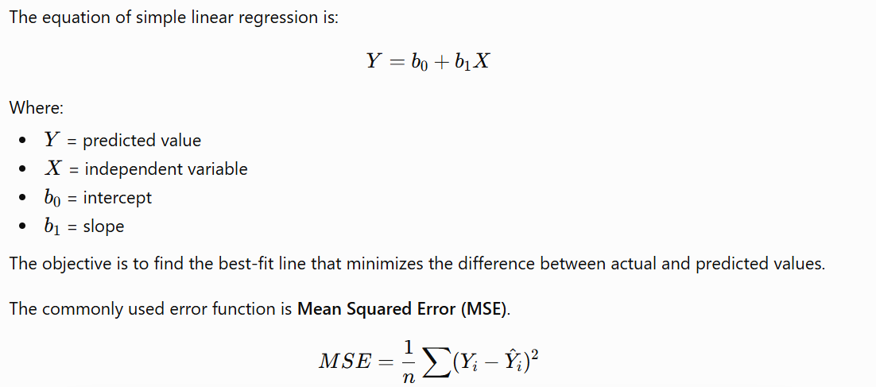Applications
- Sales prediction
- House price prediction
- Salary prediction
- Demand forecasting
- Revenue prediction
Algorithm / Steps
- Collect the dataset.
- Identify independent variable \(X\).
- Identify dependent variable \(Y\).
- Clean the dataset if required.
- Split the dataset into training and testing data.
- Calculate the required statistical values.
- Find the slope and intercept.
- Construct the regression equation.
- Train the model using training data.
- Predict values for test data.
- Calculate error/performance measures.
- Analyze the predicted results.
Result
A Linear Regression model was successfully designed and used to predict the dependent variable.

Practical 5: Design K-Means Clustering Algorithm
Aim
To design and implement the K-Means Clustering algorithm for grouping similar data points.
Theory
K-Means is an unsupervised machine learning algorithm used to divide a dataset into K clusters.
The main objective is to place similar data points in the same cluster and dissimilar points in different clusters.
Each cluster has a centroid, which represents the center of that cluster.
K-Means is widely used in:
- Customer segmentation , Image compression , Document clustering ,Market segmentation , Pattern recognition
Algorithm
- Select the number of clusters K.
- Choose K initial centroids randomly.
- Calculate the distance of every data point from each centroid.
- Assign each data point to the nearest centroid.
- Form K clusters.
- Recalculate the centroid of each cluster.
- Assign the data points again according to the new centroids.
- Repeat the assignment and centroid calculation.
- Continue until centroids do not change significantly.
- The final groups represent the required clusters.
Result
The dataset was successfully divided into K clusters using the K-Means clustering algorithm.

Practical 6: Design Hierarchical Clustering Method
Aim
To design and implement Hierarchical Clustering for grouping similar data objects.
Theory
Hierarchical clustering is an unsupervised learning technique that creates a hierarchy of clusters. The hierarchy is generally represented using a dendrogram.
There are two approaches:
1. Agglomerative Clustering
It follows a bottom-up approach.
- Initially, every data point is considered as an individual cluster.
- The closest clusters are merged repeatedly.
- The process continues until one cluster remains.
2. Divisive Clustering
It follows a top-down approach.
- Initially, all data points belong to one cluster.
- The cluster is repeatedly divided into smaller clusters.
Common linkage methods:
- Single Linkage – Minimum distance between two clusters.
- Complete Linkage – Maximum distance between two clusters.
- Average Linkage – Average distance between clusters.
Algorithm – Agglomerative
- Start with each data point as a separate cluster.
- Calculate the distance between all clusters.
- Identify the two closest clusters.
- Merge the closest clusters.
- Recalculate the distance between the newly formed cluster and other clusters.
- Again find the closest clusters.
- Continue merging clusters.
- Repeat until all points form a single cluster.
- Represent the hierarchy using a dendrogram.
- Select the required number of clusters by cutting the dendrogram.
Result
Hierarchical clustering was successfully performed and the resulting clusters were represented using a dendrogram.

Practical 7: Design Apriori Algorithm for Market Basket Analysis
Aim
To design and implement the Apriori Algorithm for Market Basket Analysis and discover frequent itemsets and association rules.
Theory
Market Basket Analysis is a data mining technique used to discover relationships between items purchased by customers.
For example:
Customers who purchase Bread may also purchase Butter.
Apriori is used to find frequent itemsets and generate association rules.
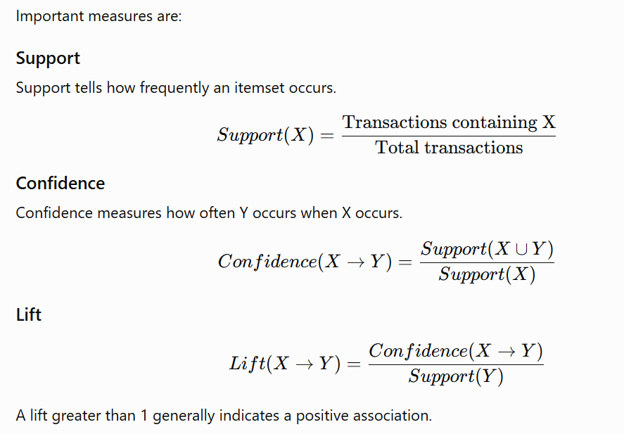Apriori Principle
If an itemset is frequent, all of its subsets must also be frequent.
Similarly, if an itemset is not frequent, its supersets cannot be frequent.
Algorithm – Apriori
- Collect the transaction database.
- Define minimum support.
- Generate candidate 1-itemsets.
- Calculate support for each itemset.
- Remove itemsets whose support is less than minimum support.
- Generate candidate 2-itemsets from frequent 1-itemsets.
- Calculate their support.
- Remove infrequent itemsets.
- Continue generating larger candidate itemsets.
- Apply the Apriori pruning principle.
- Stop when no more frequent itemsets can be generated.
- Generate association rules from frequent itemsets.
- Calculate confidence for each rule.
- Remove rules below minimum confidence.
- Calculate lift if required.
- Select the useful association rules.
Result
Frequent itemsets and useful association rules were successfully generated using the Apriori algorithm for Market Basket Analysis.
Practical 8: Sales Dashboard Creation Using Power BI
Aim
To create an interactive Sales Dashboard using Microsoft Power BI for analyzing and visualizing sales data.
Theory
Power BI is a Business Intelligence and data visualization tool used to connect, transform, analyze and visualize data.
A sales dashboard can provide important information such as:
- Total Sales
- Total Profit
- Total Quantity
- Number of Orders
- Sales by Region
- Sales by Product
- Sales by Category
- Monthly Sales Trends
- Top Performing Products
Power BI follows a general workflow:
Data Source → Power Query → Data Model → Visualizations → Dashboard
Important Power BI Components
Power Query
- Used for importing and cleaning data.
- Handles missing values, duplicates and incorrect formats.
Data Model
- Defines relationships between tables.
- Can contain fact and dimension tables.
Visualizations
- Bar chart
- Column chart
- Pie/Donut chart
- Line chart
- Map
- Table
- Cards
- Slicers
Dashboard
- Combines multiple visualizations into one interactive report.
Algorithm / Steps
- Open Power BI Desktop.
- Import the sales dataset.
- Inspect the imported data.
- Open Power Query Editor.
- Remove duplicate and incorrect records.
- Handle missing values.
- Change data types where necessary.
- Create relationships between tables.
- Create required calculated columns/measures.
- Create KPI cards for sales, profit and quantity.
- Create charts for sales by product/category.
- Create a line chart for sales over time.
- Add region/location-based visualization if required.
- Add slicers for interactive filtering.
- Format the dashboard.
- Check the relationships and calculations.
- Publish/export the completed report.
Result
An interactive Sales Dashboard was successfully created using Power BI for analyzing sales performance.

